**ER Diagram**

* **What is an ER Diagram ?**

An Entity Relationship (ER) Diagram is a type of flowchart that illustrates how “entities” such as people, objects or concepts relate to each other within a system.

* **ER diagram for college management system :**

1. **Diagram:**

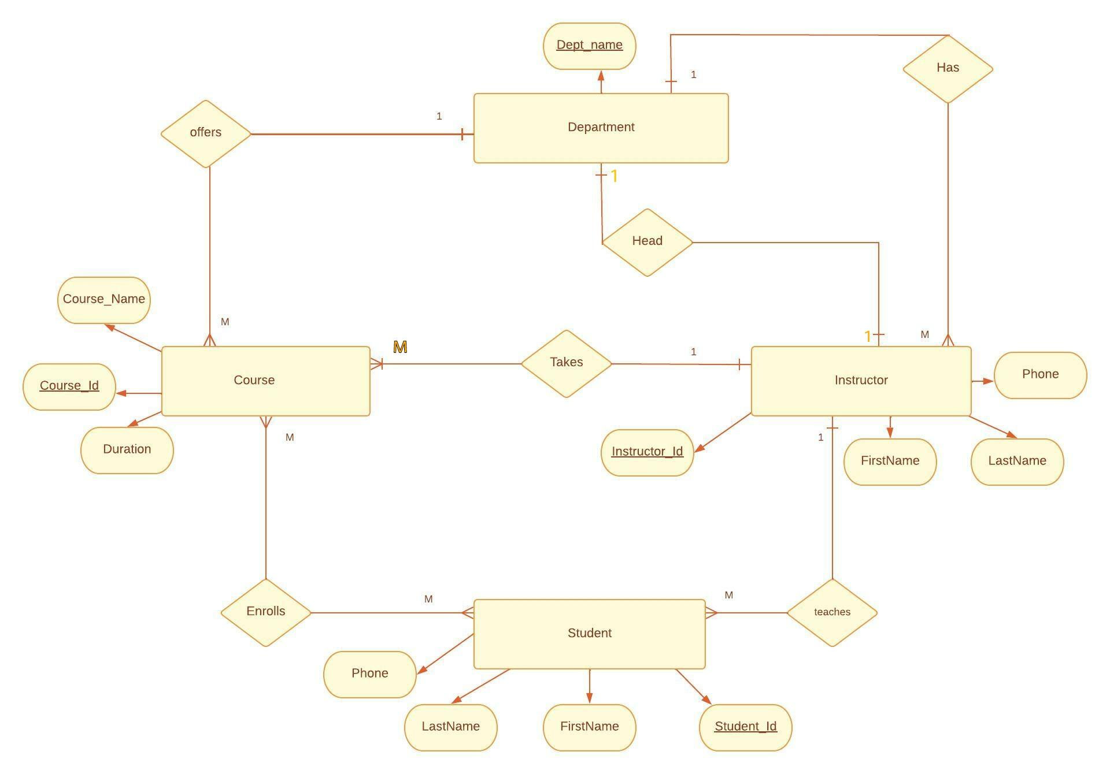

1. **Insights from the diagram:**
2. One Department can have multiple instructors
3. There can be only one head instructor in a department
4. An instructor can take many courses
5. An instructor can teach many students
6. Students can enroll in any number of courses
7. Department offers many courses

**3) Entities:**

1. Department
2. Courses
3. Instructor
4. Student

**4) Defining Attributes:**

1. **Department:**
2. Department_Name(Key Attribute)

**b) Instructor:**

1. Instructor_Id(Key Attribute)
2. Instructor_Name
3. FirstName
4. LastName
5. Phone

**c) Courses:**

1. Course_Id(Key Attribute)
2. Course_Name
3. Duration

**d) Student:**

1. Student_Id(Key Attribute)
2. FirstName
3. LastName
4. Phone